Capstone Project Report
Report 4 - Software Design Document
Learning Management System (LMS)

Item | Value
Project source | BE_LMS (ExpressJS/TypeScript) + FE_LMS (React/Vite)
Document scope | System design, package design, database design, detailed class/sequence design
Prepared date | 2026-07-16

Hanoi, July 2026

I. Record of Changes
*A - Added M - Modified D - Deleted
Date | A* M, D | In charge | Change Description
2026-07-16 | A/M | Codex | Hoàn thiện toàn bộ nội dung SDD dựa trên source code LMS: system architecture, package diagrams, database design, detailed class specifications và sequence flows.

II. Software Design Document

Document Navigation
Section | Name | Coverage
1 | System Design | Architecture, deployment view, backend/frontend package diagrams and explanations.
2 | Database Design | ERD views, collection/table descriptions, primary keys, foreign keys and constraints.
3 | Detailed Design | Class diagrams, class specifications and sequence diagrams for the main LMS flows.

This document is authored from the actual project structure and code paths under BE_LMS and FE_LMS, especially app.ts, routes, controllers, services, models, socket handlers, validators, frontend AppRoutes, services and stores.

1. System Design

1.1 System Architecture
The LMS is implemented as a MERN-style learning platform with a React/Vite single-page frontend, an ExpressJS TypeScript backend, MongoDB persistence through Mongoose, MinIO/S3 object storage, Resend transactional email and Socket.IO realtime communication.
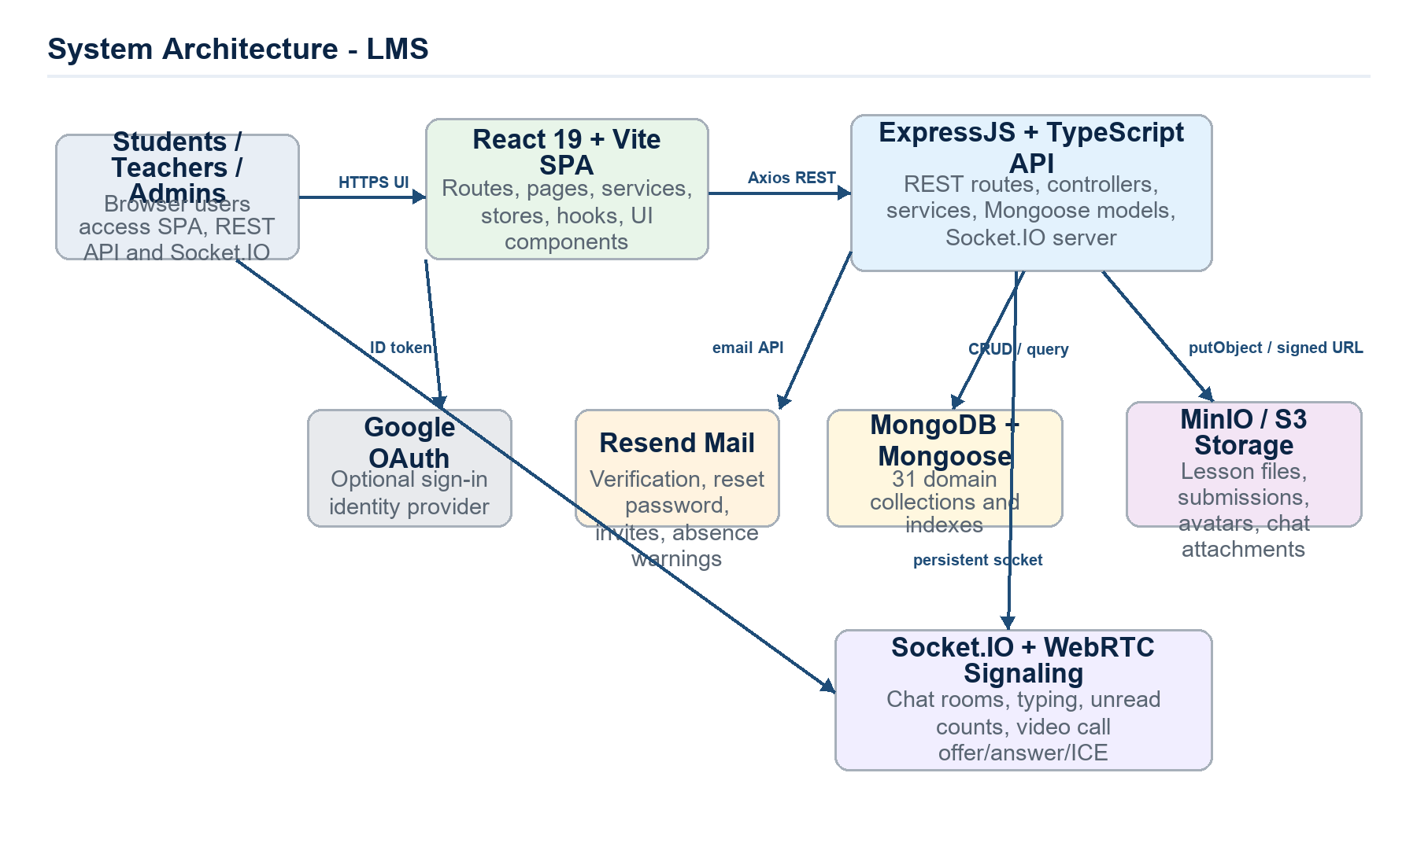
Figure 1. System architecture for LMS runtime and external integrations.
Component | Code Location | Design Responsibility
React/Vite SPA | FE_LMS | Delivers pages, protected routes, dashboards and feature UI. Uses Axios services to call backend APIs and Socket.IO client for realtime chat/video.
Express API | BE_LMS/src/app.ts | Registers REST endpoints, CORS, cookies, custom response middleware, error handler, multer upload and Socket.IO server.
MongoDB/Mongoose | BE_LMS/src/models | Stores all business documents using 31 Mongoose models with refs and indexes.
MinIO/S3 | BE_LMS/src/config/minio.ts, utils/uploadFile.ts | Stores binary files: lesson material, course logo, submissions, feedback attachments and chat files.
Resend | BE_LMS/src/utils/sendMail.ts | Sends email verification, password reset, invite and absence warning emails.
Socket.IO | BE_LMS/src/socket | Authenticates socket by JWT cookie, joins chat rooms, broadcasts messages and relays WebRTC signaling.
Google OAuth | auth.service.ts | Optional OAuth login; creates/updates verified users and sessions.

Key architectural rule: HTTP request processing follows the same chain across modules: route -> middleware -> controller -> validator -> service -> model/external integration -> custom response. Realtime events follow socket middleware -> event handler -> service/model -> room emission.

1.2 Package Diagram
The backend is organized as a layered architecture. routes and socket are the entry points, controllers coordinate request/response, services own business rules, models own persistence, while middleware/validators/utils/config/types/constants are cross-cutting support packages.
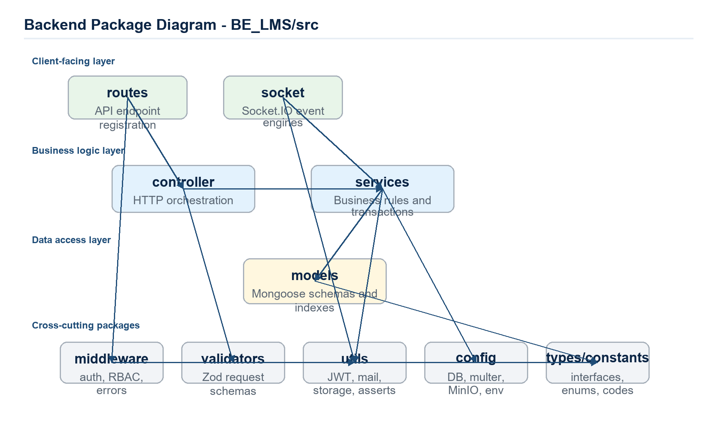
Figure 2. Backend package diagram.
No | Package | Description
01 | routes | Đăng ký endpoint REST như /auth, /courses, /enrollments, /quiz-attempts; gắn middleware authenticate/authorize và chuyển request đến controller.
02 | controller | Nhận request/response Express, parse dữ liệu qua validator, lấy user context từ middleware và gọi service tương ứng.
03 | services | Chứa nghiệp vụ lõi: kiểm tra prerequisite, capacity, cooldown, grading, attendance threshold, soft delete và transaction.
04 | models | Định nghĩa Mongoose schema, collection, ref, index và hook cho 31 entity nghiệp vụ.
05 | middleware | Xác thực JWT, phân quyền RBAC, response helper, error handler tập trung.
06 | validators | Schema kiểm tra request theo từng module để chặn dữ liệu sai trước khi vào service.
07 | socket | Khởi tạo Socket.IO, xác thực socket qua cookie, xử lý chat room, typing, seen state và WebRTC signaling.
08 | config | Cấu hình MongoDB, Multer memory storage, MinIO/S3 client, Resend và biến môi trường.
09 | utils | Hàm dùng chung: JWT, bcrypt, sendMail, uploadFile, presigned URL, prefix file, appAssert/AppError.
10 | types | Interface, enum và DTO TypeScript: Role, CourseStatus, EnrollmentStatus, AttemptStatus, AttendanceStatus...
11 | constants | HTTP status, mã lỗi ứng dụng, regex, giới hạn field, env constants.

The frontend separates navigation, feature pages, reusable components, service clients, state stores, hooks and shared type definitions. This keeps API integration and UI rendering independent while still matching the backend module names.
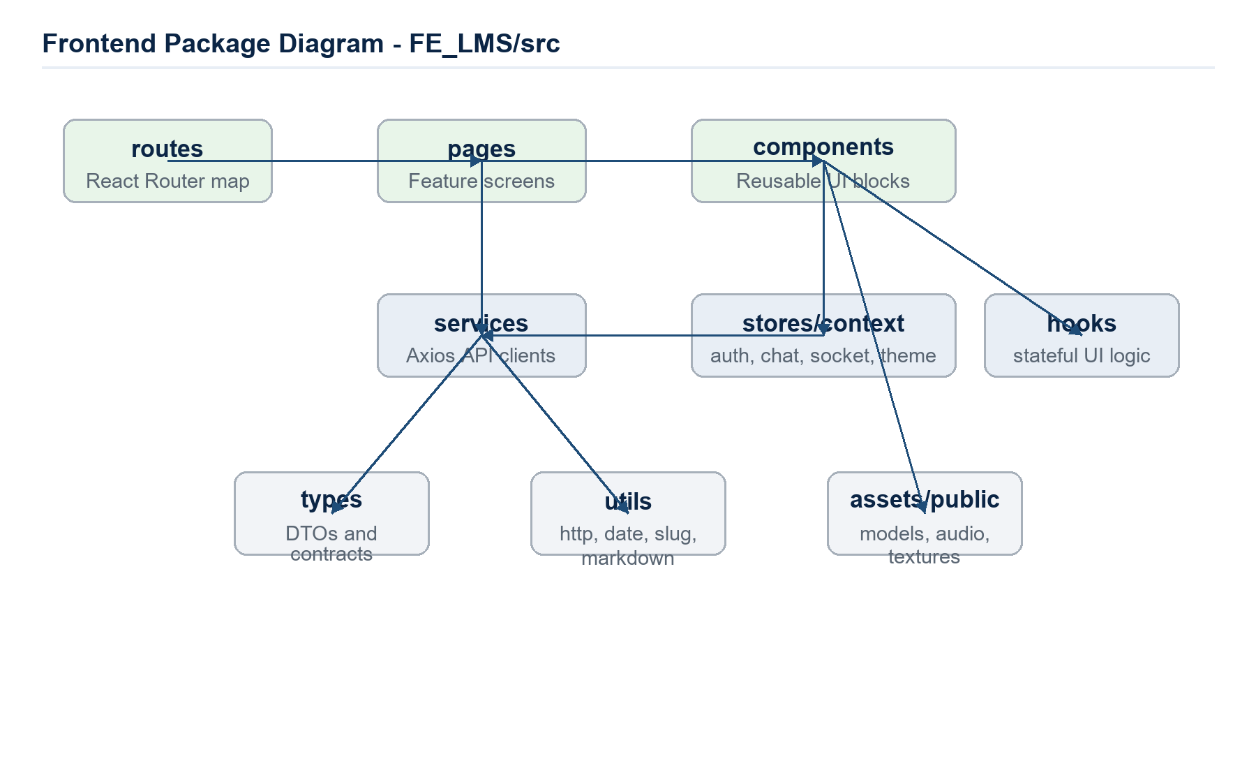
Figure 3. Frontend package diagram.
No | Package | Description
01 | routes | Khai báo React Router, ProtectedRoute và phân nhánh màn hình theo student/teacher/admin.
02 | pages | Các màn hình nghiệp vụ: dashboard, courses, quizzes, assignments, attendance, forum, chat, feedback, curriculum.
03 | components | UI tái sử dụng: layout, course tabs, quiz cards, calendar, chat window, video call, lesson material viewer.
04 | services | Axios API client theo module: auth, course, enrollment, quiz, submission, lesson material, chat room...
05 | stores/context | State chung bằng Zustand/Context: auth, chat rooms, floating chat, video call, socket, theme.
06 | hooks | Hook điều phối message, unread chat, video call, debounce, auth và theme.
07 | types | TypeScript contract dùng ở FE cho Course, Quiz, Assignment, Schedule, Feedback, Auth...
08 | utils | Tiện ích HTTP, date, slug, markdown sanitize/render.
09 | assets/public | Texture, model, audio và tài nguyên tĩnh dùng cho trải nghiệm học tập.

2. Database Design
The database layer uses MongoDB documents through Mongoose. All collections use MongoDB _id as the primary key. Relationships are represented through ObjectId refs, with indexes used for uniqueness, filtering and operational safety.
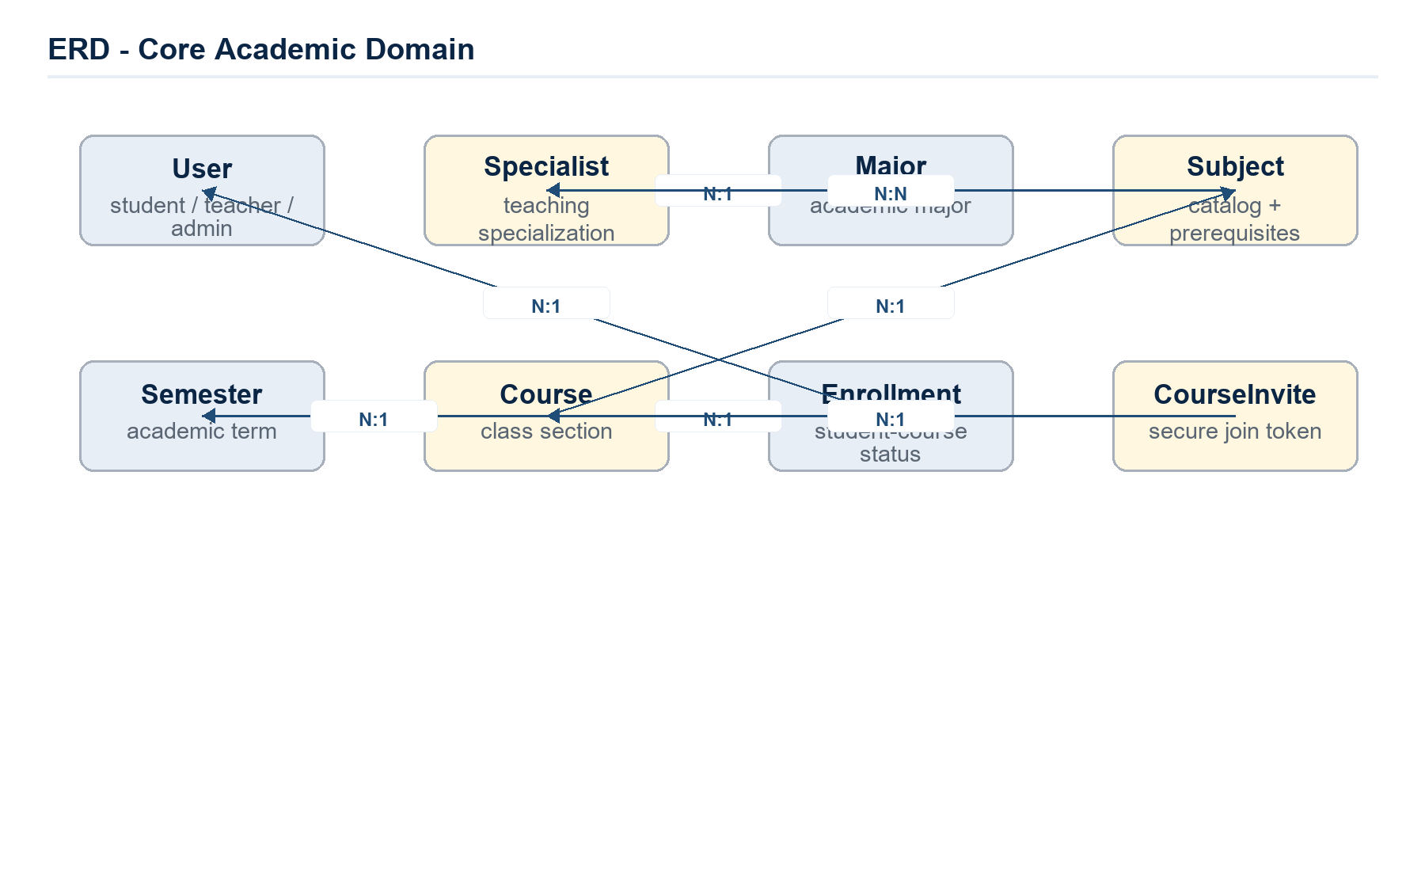
Figure 4. ERD for core academic domain.
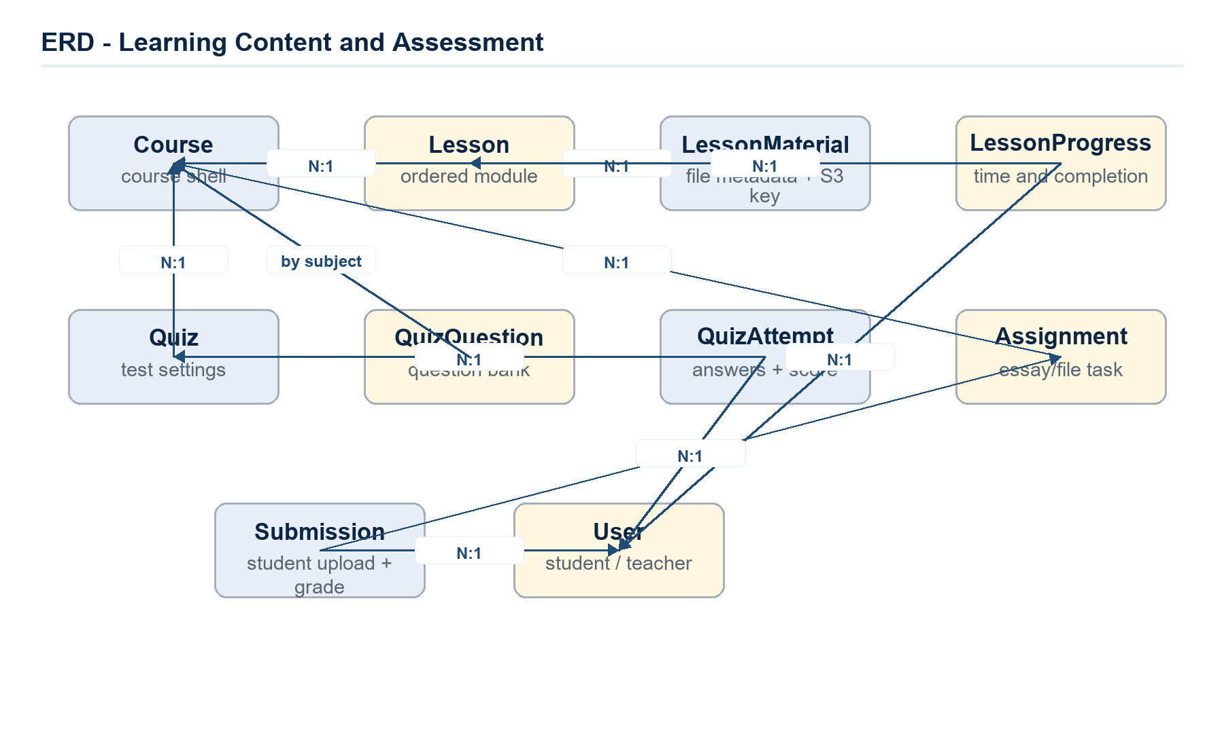
Figure 5. ERD for learning content and assessment.
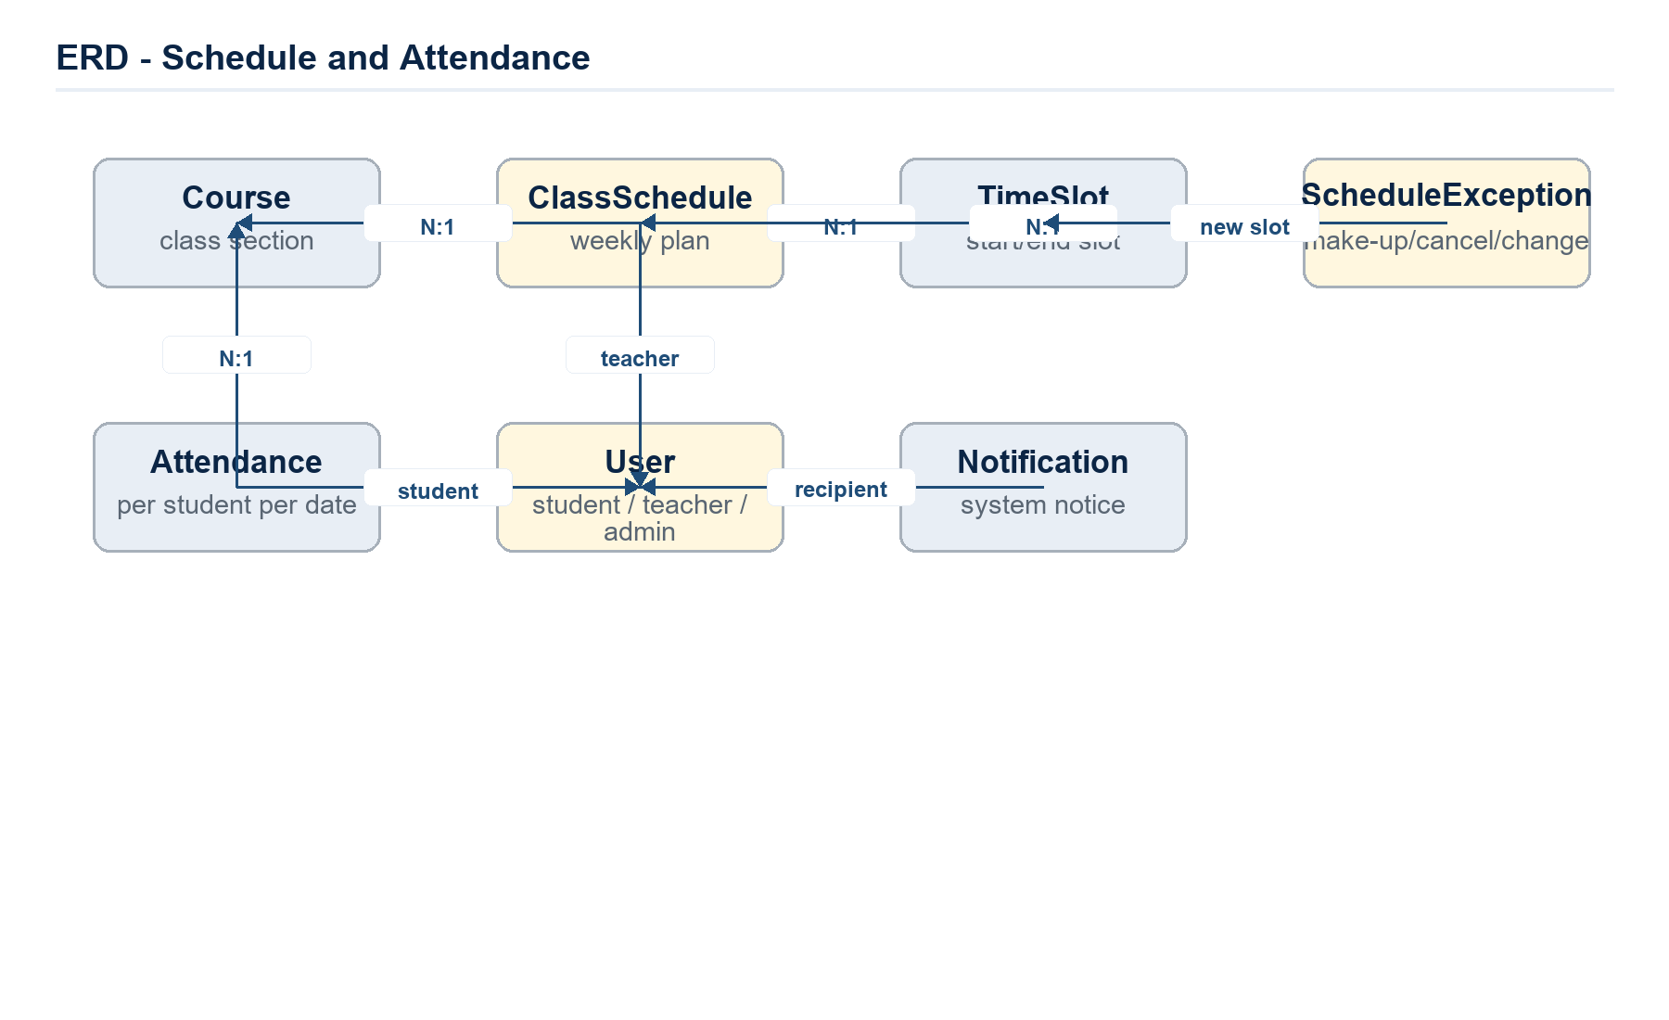
Figure 6. ERD for schedule and attendance.
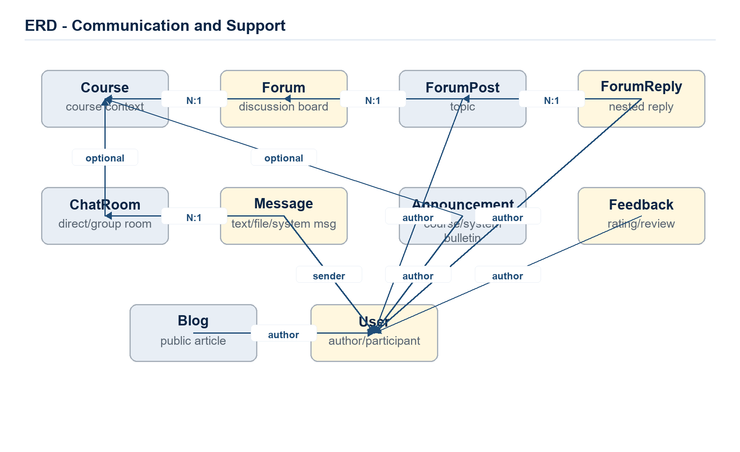
Figure 7. ERD for communication and support modules.

Table Descriptions
No | Table / Collection | Primary Key | Foreign Keys | Description
01 | User | _id | specialistIds -> Specialist | Tài khoản Student/Teacher/Admin; lưu email, mật khẩu bcrypt, role, trạng thái, hồ sơ, Google ID.
02 | Session | _id | userId -> User | Phiên đăng nhập dùng cho refresh token, user agent và thời hạn session.
03 | VerificationCode | _id | userId -> User | Mã tạm thời cho verify email và reset password, có email/type/expiresAt.
04 | Specialist | _id | majorId -> Major | Chuyên ngành dùng để ràng buộc giáo viên với Subject/Course phù hợp.
05 | Major | _id | - | Ngành học hoặc khoa, có name/slug/description và timestamp.
06 | Subject | _id | specialistIds -> Specialist; prerequisites -> Subject | Môn học chuẩn trong catalog; hỗ trợ prerequisite map, code, credits, active flag.
07 | Semester | _id | - | Học kỳ/năm học với startDate/endDate; ràng buộc unique theo name và year/type.
08 | Course | _id | semesterId -> Semester; subjectId -> Subject; teacherIds/createdBy/deletedBy -> User | Lớp học cụ thể của một subject; có status draft/ongoing/completed, capacity, publish flag, weight, soft delete.
09 | CourseInvite | _id | courseId -> Course; createdBy -> User | Token join course có hash, expiry, maxUses, usedCount, active/deleted flags.
10 | Enrollment | _id | studentId/respondedBy -> User; courseId -> Course | Bản ghi student tham gia course; trạng thái pending/approved/rejected/cancelled/dropped/completed và progress tổng hợp.
11 | Lesson | _id | courseId -> Course; createdBy -> User | Bài học trong course, có thứ tự, nội dung, duration, publish status.
12 | LessonMaterial | _id | lessonId -> Lesson; uploadedBy -> User | Metadata tài liệu: title, note, originalName, mimeType, key MinIO, size.
13 | LessonProgress | _id | lessonId -> Lesson; courseId -> Course; studentId -> User | Theo dõi completedAt, timeSpentSeconds, lastAccessedAt cho từng student/lesson.
14 | Quiz | _id | courseId -> Course; createdBy -> User | Cấu hình quiz: title, time window, shuffleQuestions, snapshotQuestions, published flag.
15 | QuizQuestion | _id | subjectId -> Subject | Ngân hàng câu hỏi; lưu text, images, options, correctOptions, points, explanation.
16 | QuizAttempt | _id | quizId -> Quiz; studentId -> User | Lượt làm bài; lưu startedAt, submittedAt, duration, answers, score, status.
17 | Assignment | _id | courseId -> Course; createdBy -> User | Bài tập tự luận/file upload; có maxScore, dueDate, allowLate và file đính kèm của đề.
18 | Submission | _id | assignmentId -> Assignment; studentId/gradedBy -> User | Bài nộp của student; lưu file key, trạng thái, điểm, feedback, gradeHistory, isLate.
19 | ClassSchedule | _id | courseId -> Course; teacherId/requestedBy/approvedBy -> User; timeSlotId -> TimeSlot | Lịch học tuần; model name là ClassSchedule, collection classschedules; có status và recurrencePattern.
20 | TimeSlot | _id | createdBy -> User | Ca học chuẩn: slotNumber, startTime, endTime, duration, applicableDays.
21 | ScheduleException | _id | scheduleId -> ClassSchedule; courseId -> Course; newTimeSlotId -> TimeSlot; replacementTeacherId/requestedBy/approvedBy -> User | Ngoại lệ lịch học: hủy, học bù, đổi phòng, đổi giáo viên, trạng thái duyệt.
22 | Attendance | _id | courseId -> Course; studentId/markedBy -> User | Điểm danh theo course-student-date, status notyet/present/absent; unique theo courseId/studentId/date.
23 | Forum | _id | courseId -> Course; createdBy -> User | Không gian thảo luận theo course; có title/description và text index.
24 | ForumPost | _id | forumId -> Forum; authorId -> User | Chủ đề thảo luận trong forum, hỗ trợ pinned và index theo forum/author.
25 | ForumReply | _id | postId -> ForumPost; authorId -> User; parentReplyId -> ForumReply | Reply phân cấp cho forum post.
26 | ChatRoom | _id | courseId -> Course; participants.userId/createdBy/seenBy -> User; lastMessage.id -> Message | Phòng chat trực tiếp/nhóm; lưu participants, lastMessage, unreadCounts.
27 | Message | _id | chatRoomId -> ChatRoom; senderId -> User | Tin nhắn text/link/file/system trong chat room; có metadata file khi gửi đính kèm.
28 | Notification | _id | sender/recipientUser -> User; recipientCourse -> Course | Thông báo trong hệ thống; có recipientType, isRead, soft delete.
29 | Announcement | _id | courseId -> Course; authorId -> User | Thông báo course/system với title/content/publishedAt.
30 | Blog | _id | - | Bài viết public; có title, slug unique, content, thumbnailUrl, authorName, avatar.
31 | Feedback | _id | userId -> User; targetId -> dynamic target | Đánh giá/rating và phản hồi có thể kèm file minh chứng; targetId dùng cho course/teacher/system tùy type.

Important Constraints and Indexes
Entity | Constraint / Index | Design Purpose
Enrollment | Unique { studentId, courseId } | Prevents duplicated enrollment records for the same student and course.
Attendance | Unique { courseId, studentId, date } | Allows exactly one attendance status per student per course session date.
Course | Unique slug; indexes on isPublished/status/isDeleted | Supports public listing, recycle bin and course detail lookup.
Subject | Unique name/code/slug; prerequisite refs | Protects catalog identity and prerequisite map.
ClassSchedule | Unique active teacher-day-timeSlot partial index | Prevents teacher double-booking when schedule is approved/active.
LessonProgress | Unique { studentId, lessonId } | Keeps one progress record per student per lesson.
QuizAttempt | Unique { quizId, studentId } | Controls a single attempt record per quiz/student in current design.
CourseInvite | Unique tokenHash | Protects invite tokens and allows revocation/expiry checks.

3. Detailed Design
This section documents the principal LMS flows from UI trigger to persistence/external integration. Similar modules share the same layered pattern, so each feature presents the relevant classes, responsibilities and a representative sequence diagram.

3.1 Authentication & Session Management
Đảm bảo người dùng đăng ký, xác thực email, đăng nhập, refresh token, logout và reset password bằng luồng an toàn dựa trên JWT cookie + SessionModel.
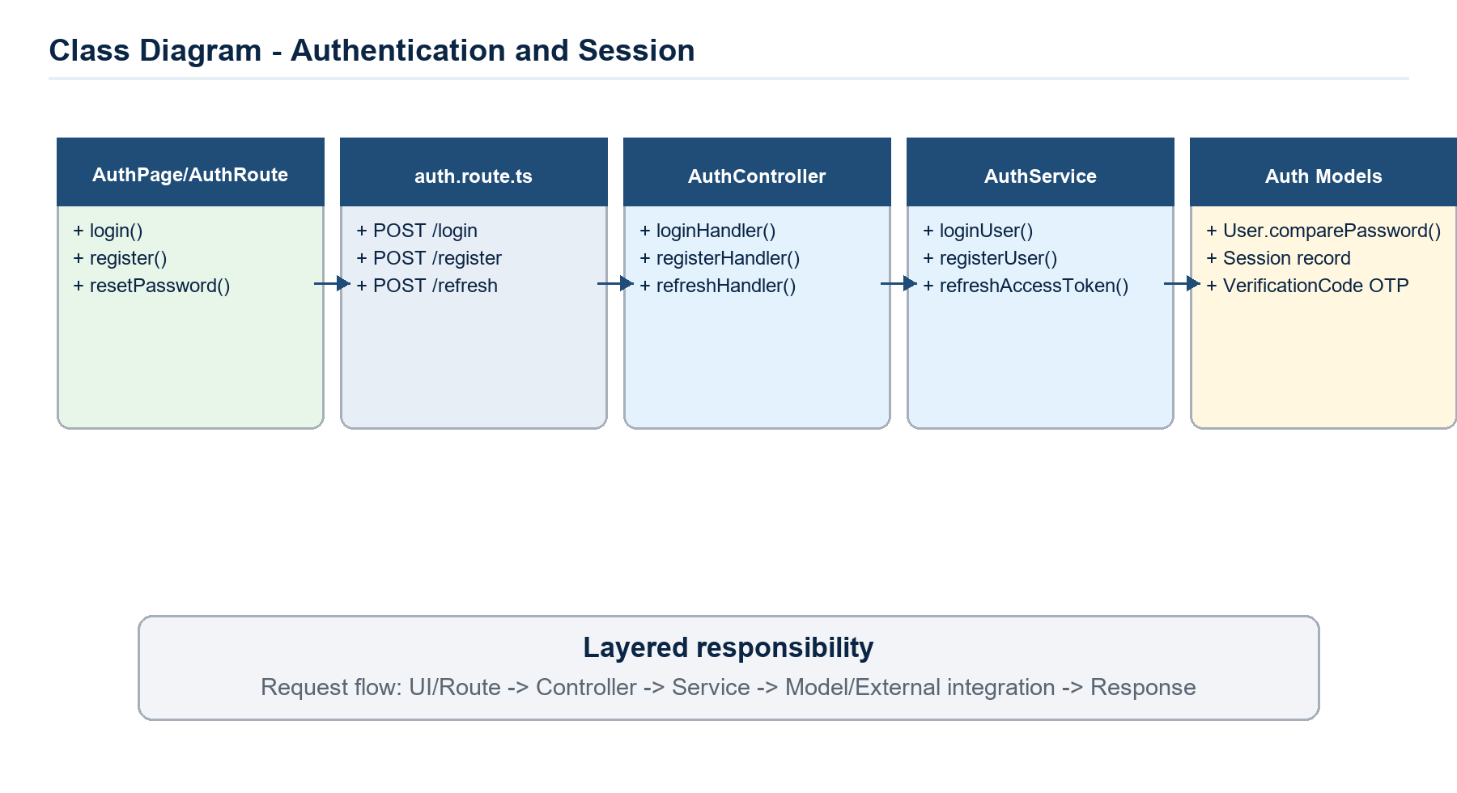
Class Diagram - Authentication & Session Management.
Class / Module | Specification
AuthController | registerHandler, loginHandler, refreshHandler, verifyEmailHandler, resetPasswordHandler
AuthService | registerUser, loginUser, refreshUserAccessToken, verifyEmail, resetPassword, googleLogin
UserModel | So sánh mật khẩu bằng comparePassword(), lưu role/status/isVerified/specialistIds.
SessionModel | Lưu sessionId trong refresh token, expiresAt và userAgent.
VerificationCodeModel | Lưu OTP/link verify email hoặc forgot password.

Main sequence and business flow:
- Register: FE gửi /auth/register, service kiểm tra email trùng, tạo User, tạo VerificationCode và gửi email qua Resend.
- Login: service tìm user theo email, so sánh bcrypt, tạo Session, ký accessToken/refreshToken và controller set HTTP-only cookies.
- Refresh: controller đọc refreshToken cookie, service xác thực session còn hạn, gia hạn session nếu gần hết hạn và trả accessToken mới.
- Reset password: service xác thực VerificationCode loại FORGOT_PASSWORD, hash mật khẩu mới, xóa session cũ để buộc đăng nhập lại.
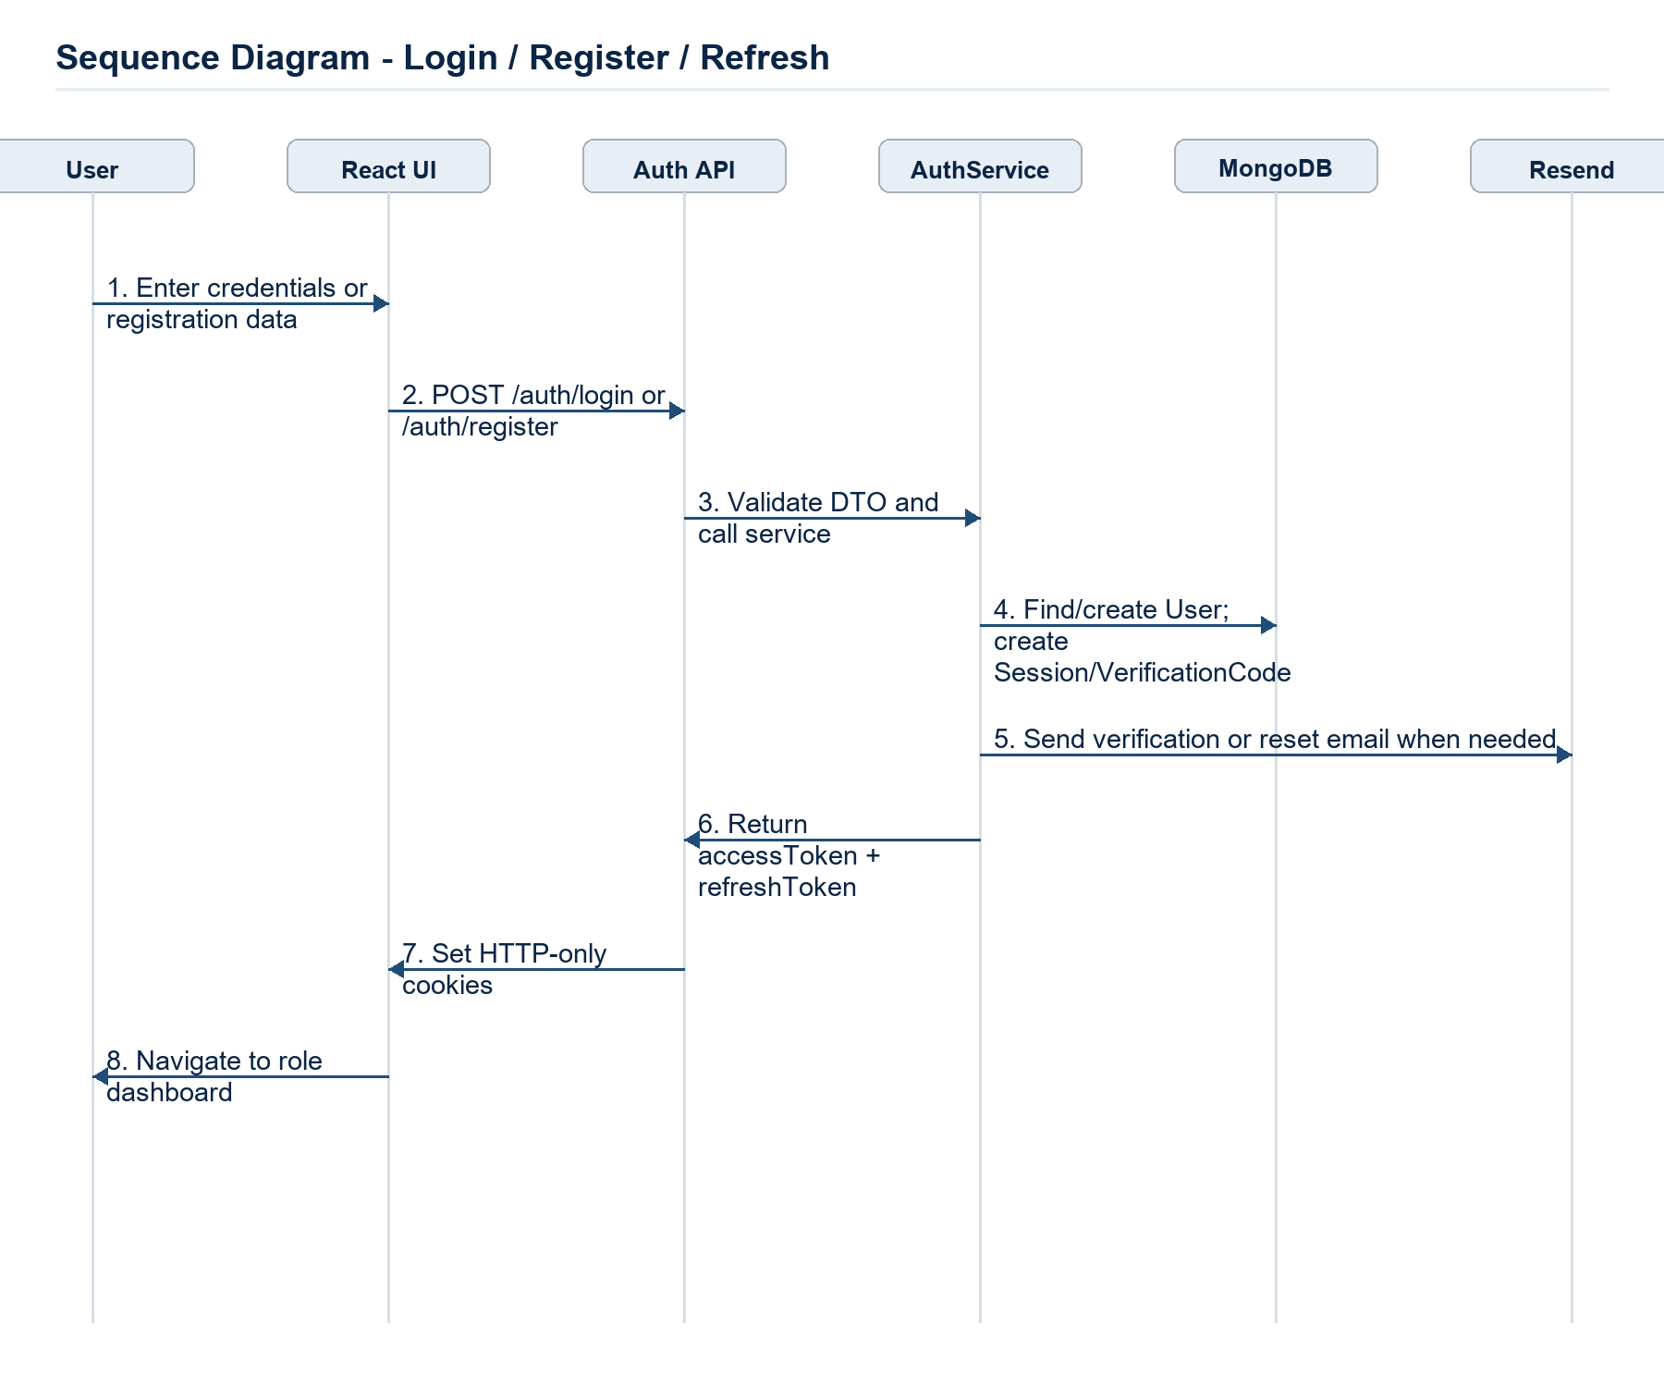
Sequence Diagram - Authentication & Session Management.

3.2 Course, Curriculum & Enrollment
Thiết kế luồng tạo course, publish course, self-enroll và quản lý trạng thái học tập dựa trên CourseStatus, EnrollmentStatus và prerequisite map của Subject.
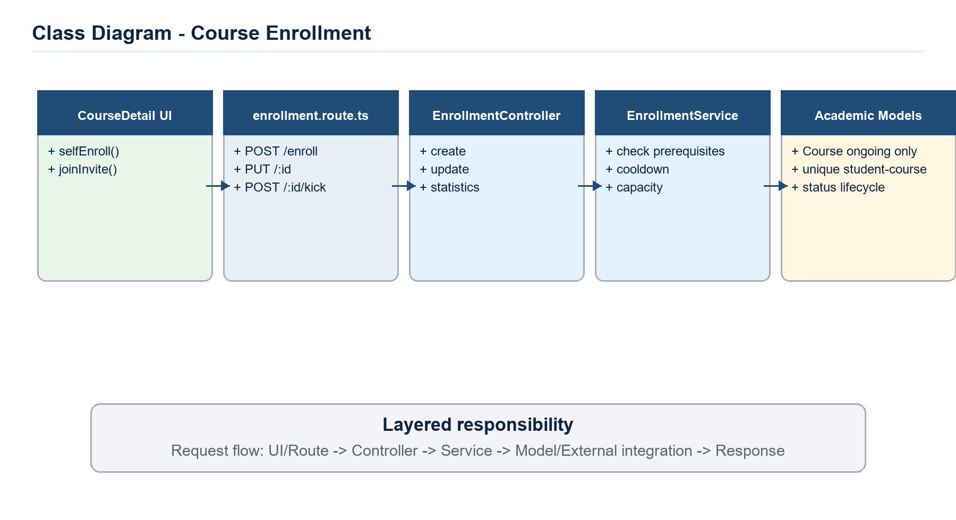
Class Diagram - Course, Curriculum & Enrollment.
Class / Module | Specification
CourseController/Service | list, create, update, soft delete, restore, complete course, statistics
EnrollmentController/Service | self enroll, admin enroll, update status, kick student, enrollment statistics
SubjectModel | Quản lý code/slug/specialistIds/prerequisites.
CourseModel | semesterId, subjectId, teacherIds, capacity, weight, status, isPublished, soft delete.
EnrollmentModel | studentId + courseId unique, status lifecycle, progress and finalGrade.

Main sequence and business flow:
- Teacher/Admin tạo Course ở draft; service bắt buộc có teacherIds, capacity hợp lệ, teacher active và specialist của teacher phải match specialist của Subject.
- Admin publish course: isPublished=true sẽ chuyển status từ draft sang ongoing và thông báo cho teacher.
- Student self-enroll: chỉ nhận course ongoing, kiểm tra prerequisite đã completed, password nếu có, cooldown 1 phút khi re-enroll và capacity còn chỗ.
- Teacher/Admin cập nhật enrollment: approval/rejection/completed/dropped tạo timestamp tương ứng và gửi Notification cho student.
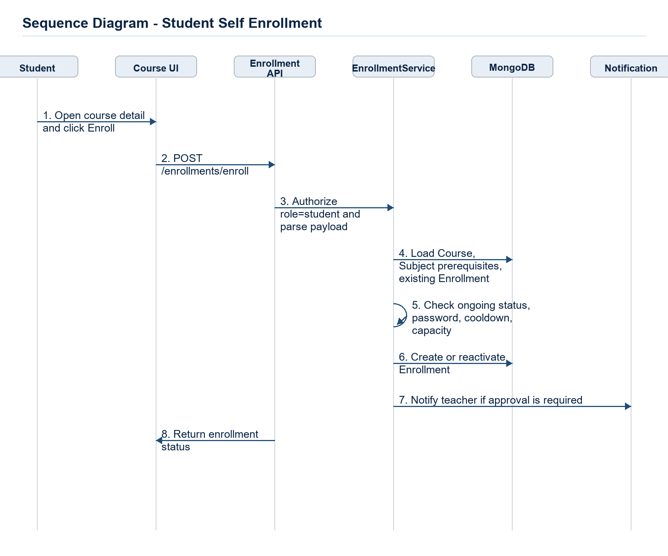
Sequence Diagram - Course, Curriculum & Enrollment.

3.3 Lessons, Materials & Learning Progress
Quản lý cấu trúc bài học, tài liệu học tập trên MinIO/S3 và tiến độ học tập cá nhân của student.
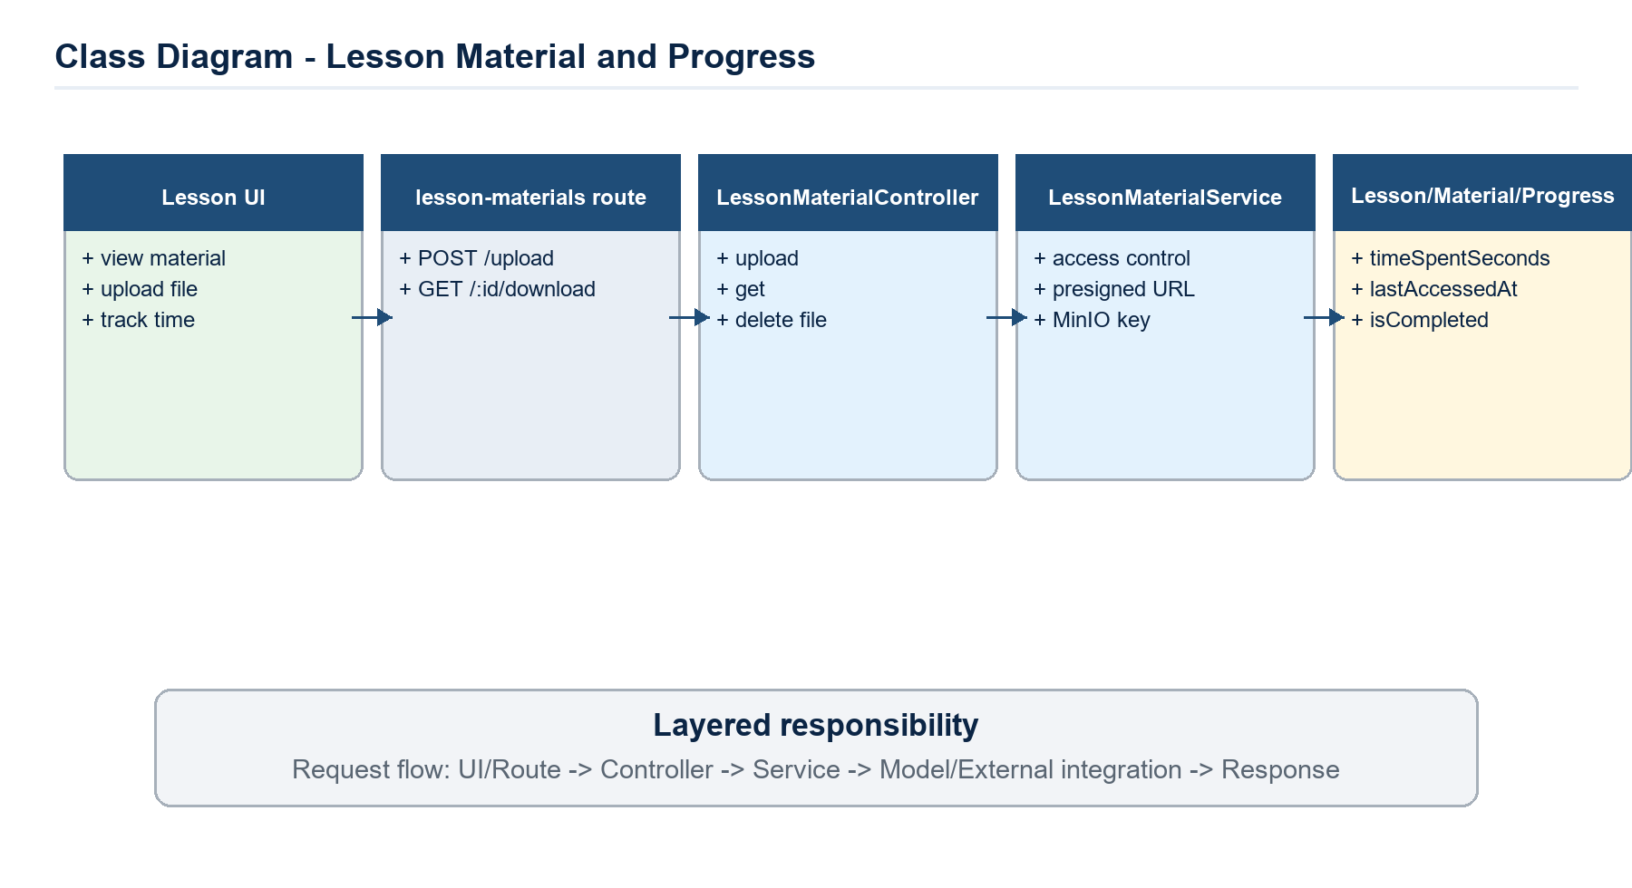
Class Diagram - Lessons, Materials & Learning Progress.
Class / Module | Specification
LessonController/Service | create/update/delete lesson, list by course, enforce order.
LessonMaterialService | role-based access, uploadFile, removeFile, presigned URL.
LessonProgressService | add time, mark complete, get lesson/course progress.
MinIO Client | putObject, removeObject, presignedGetObject.
Lesson/LessonMaterial/LessonProgress | metadata and tracking models.

Main sequence and business flow:
- Teacher upload tài liệu qua /lesson-materials/upload; Multer memoryStorage kiểm tra MIME và limit 20MB.
- Service xác nhận user là instructor của course, upload file lên MinIO với prefix theo course/lesson, lưu key/originalName/mimeType/size.
- Student mở bài học; service xác nhận enrollment, đọc material metadata và tạo presigned URL để tải/stream file.
- FE gửi heartbeat PATCH /lesson-progress/lessons/:lessonId/time; service cộng timeSpentSeconds và cập nhật lastAccessedAt.
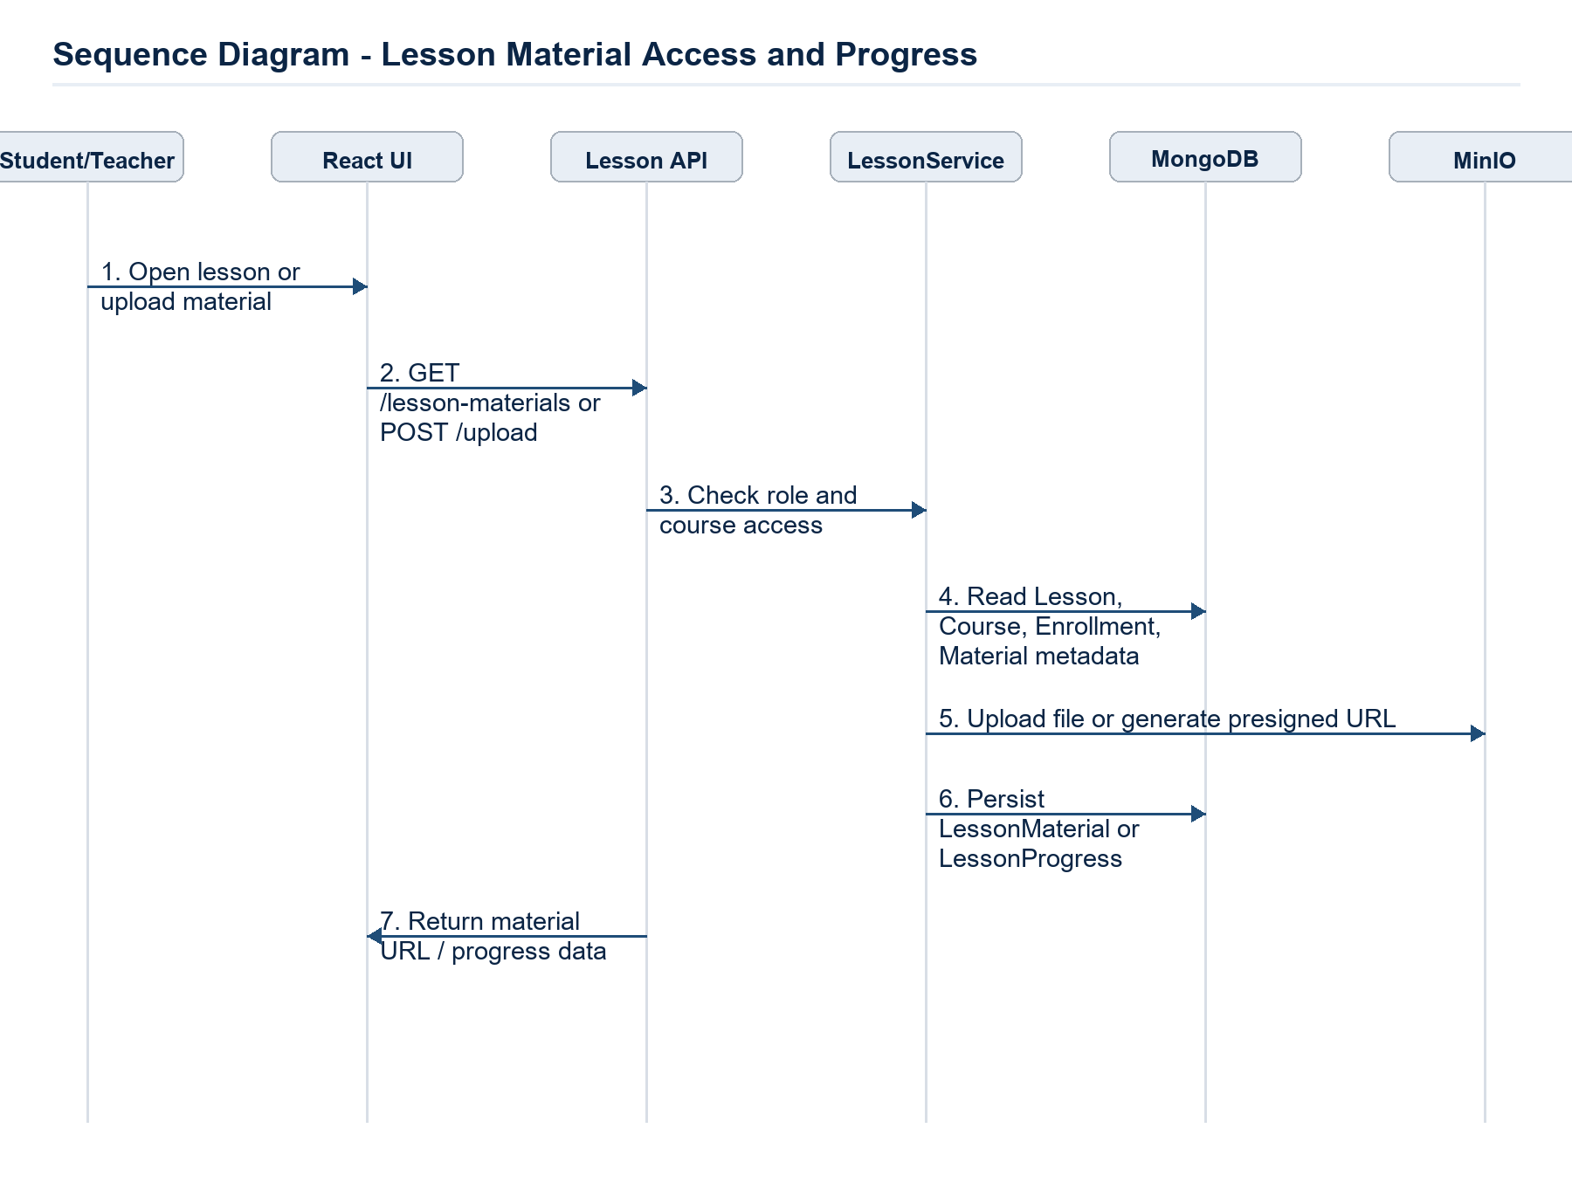
Sequence Diagram - Lessons, Materials & Learning Progress.

3.4 Quiz, Question Bank & Attempt Lifecycle
Thiết kế ngân hàng câu hỏi, quiz được publish theo course, lượt làm bài có auto-save, submit, ban và re-grade.
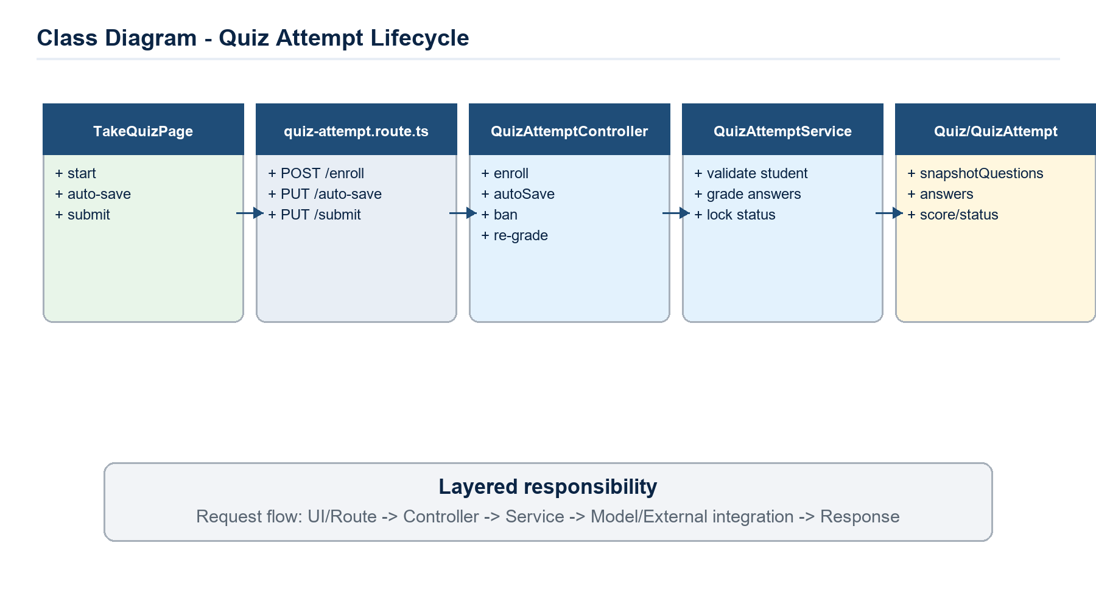
Class Diagram - Quiz, Question Bank & Attempt Lifecycle.
Class / Module | Specification
QuizQuestionService | import/export XML, random question selection, CRUD question bank.
QuizService | create/update/delete quiz, snapshotQuestions, statistics.
QuizAttemptService | enroll, save, autoSave, submit, ban, re-grade.
QuizAttemptModel | answers, score, status in_progress/submitted/abandoned.
QuizModel | time window, shuffleQuestions, hashPassword, isPublished.

Main sequence and business flow:
- Teacher tạo quiz từ bank hoặc snapshotQuestions; route /quizzes yêu cầu role teacher/admin.
- Student start quiz qua /quiz-attempts/enroll; service xác nhận enrollment approved và không bị abandoned/submitted.
- Trong lúc làm bài, FE gọi /quiz-attempts/:id/auto-save; service ghi answers nháp để chống mất dữ liệu.
- Submit: service grade answers, cập nhật score/status=submitted/submittedAt; teacher/admin có thể ban hoặc re-grade khi có sự cố.
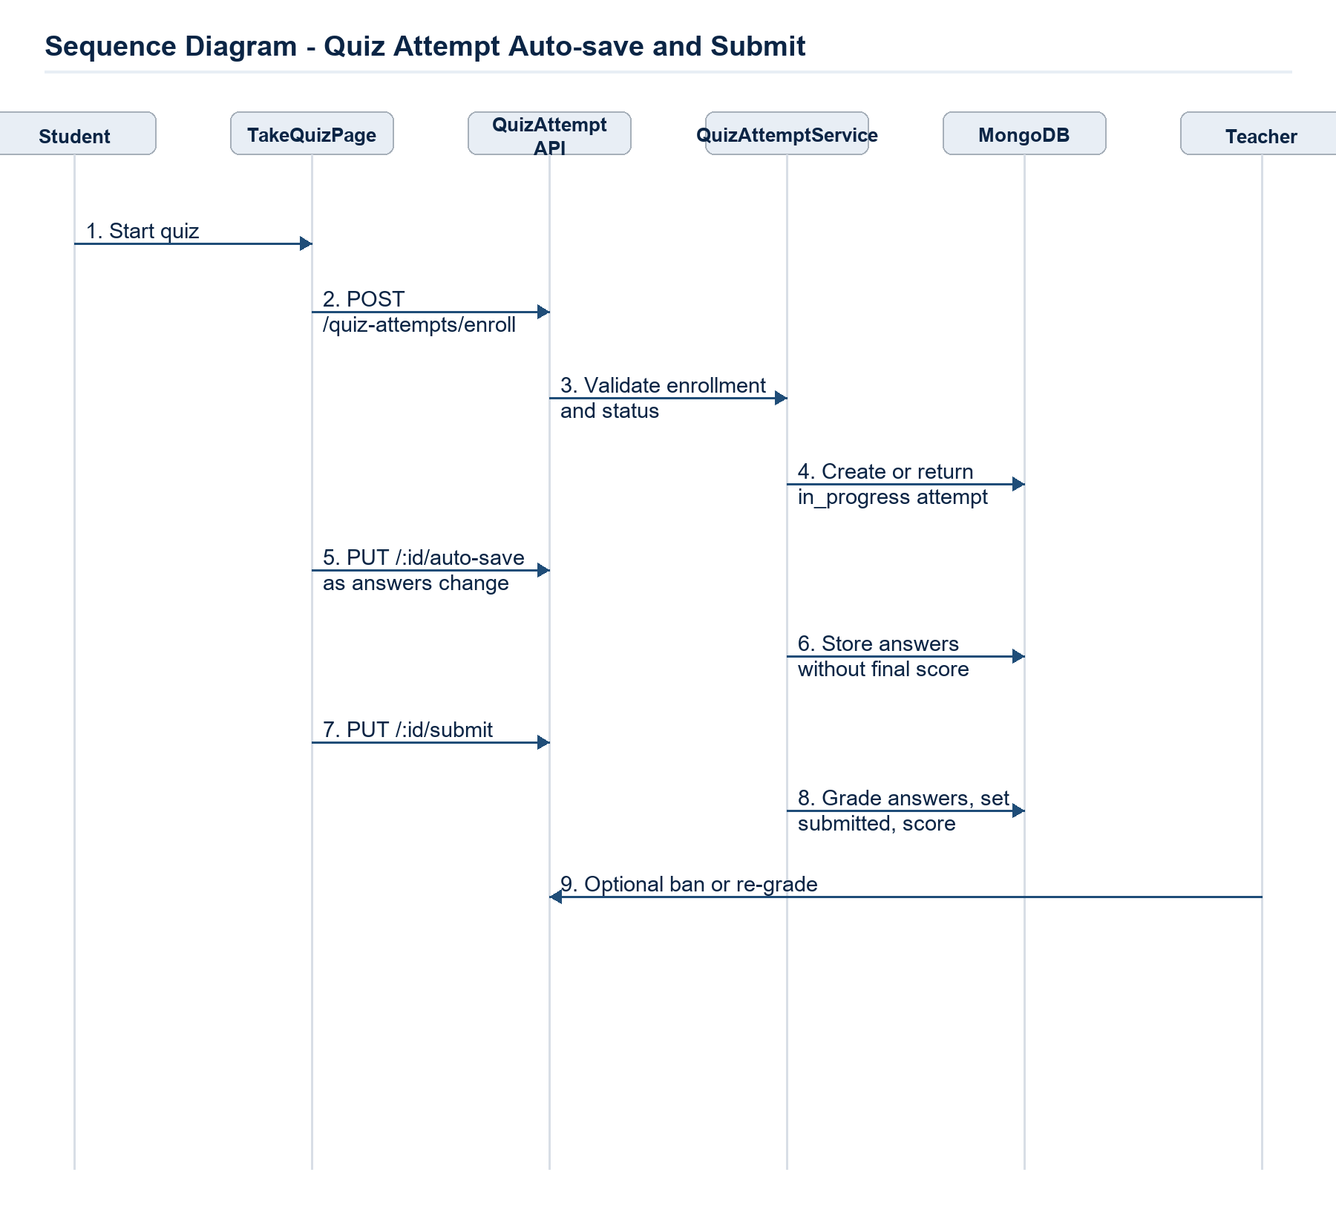
Sequence Diagram - Quiz, Question Bank & Attempt Lifecycle.

3.5 Assignments, Submissions & Grading
Hỗ trợ teacher tạo bài tập, student nộp file, teacher chấm điểm và xem thống kê/report.
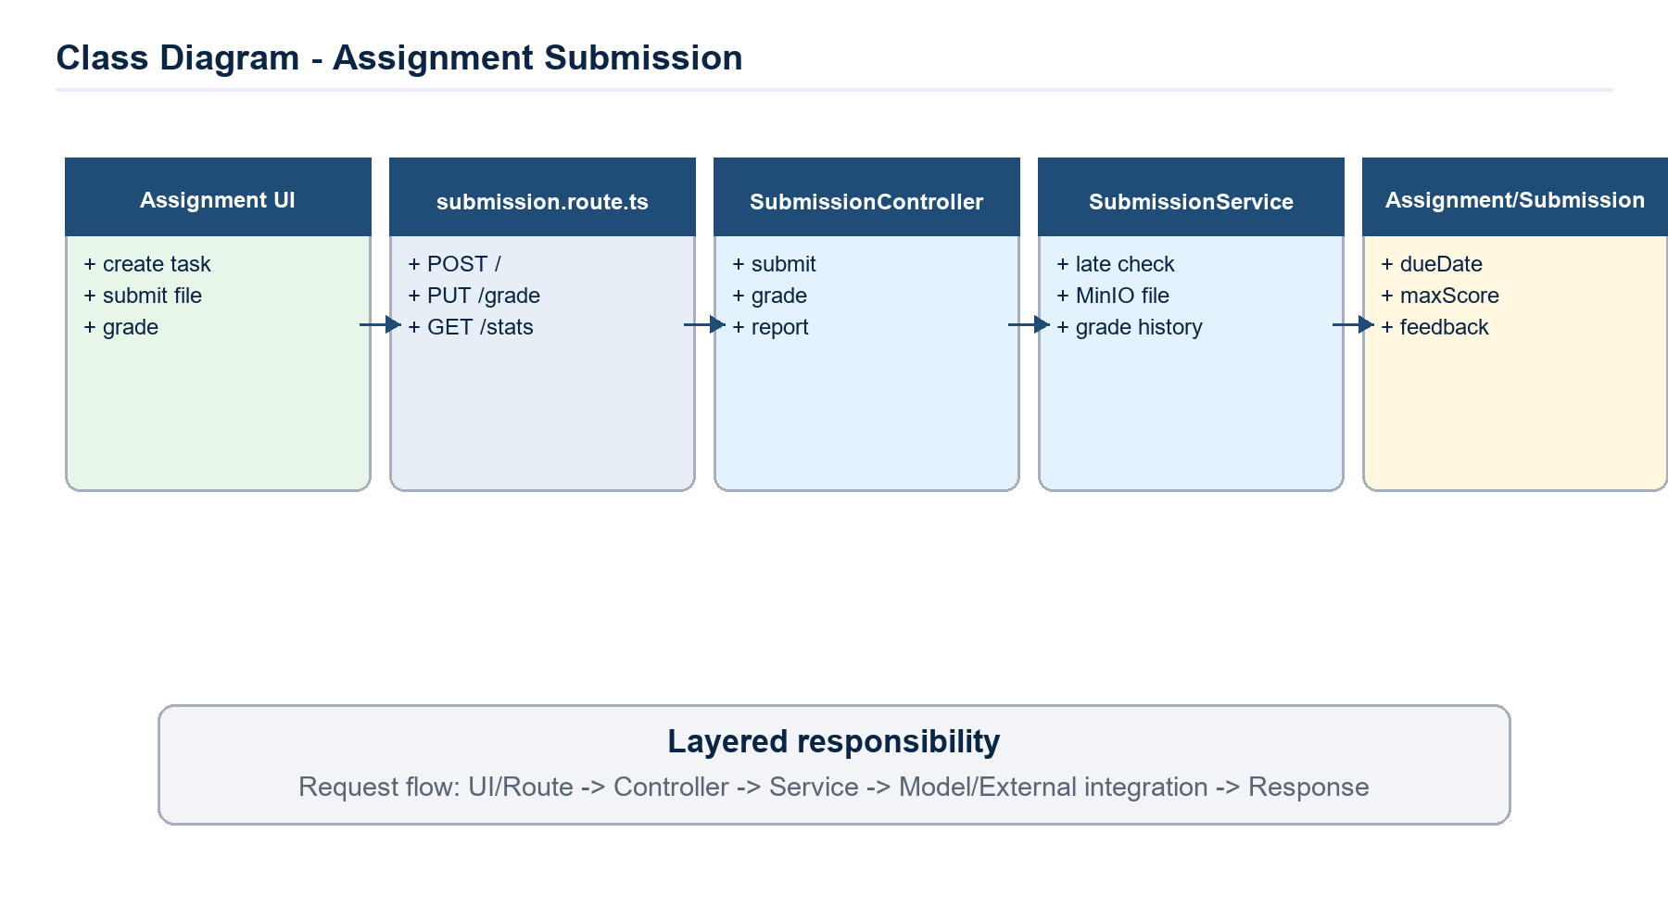
Class Diagram - Assignments, Submissions & Grading.
Class / Module | Specification
AssignmentService | CRUD assignment, course scope, deadline/maxScore.
SubmissionService | submit/resubmit, status, late check, grade and reports.
UploadFile utility | MinIO upload and metadata extraction.
AssignmentModel | courseId, title, maxScore, dueDate, allowLate, file metadata.
SubmissionModel | assignmentId, studentId, file key, grade, feedback, gradeHistory.

Main sequence and business flow:
- Teacher tạo Assignment cho course, có dueDate, maxScore và optional file đề bài.
- Student nộp bài qua /submissions; service kiểm tra quyền học course, deadline/allowLate, upload file lên MinIO và lưu Submission.
- Teacher chấm qua /submissions/:assignmentId/grade hoặc /by-submission/:id/grade; service lưu grade, feedback và gradeHistory.
- Teacher/Admin xem stats/report theo assignment hoặc course để tổng hợp điểm.
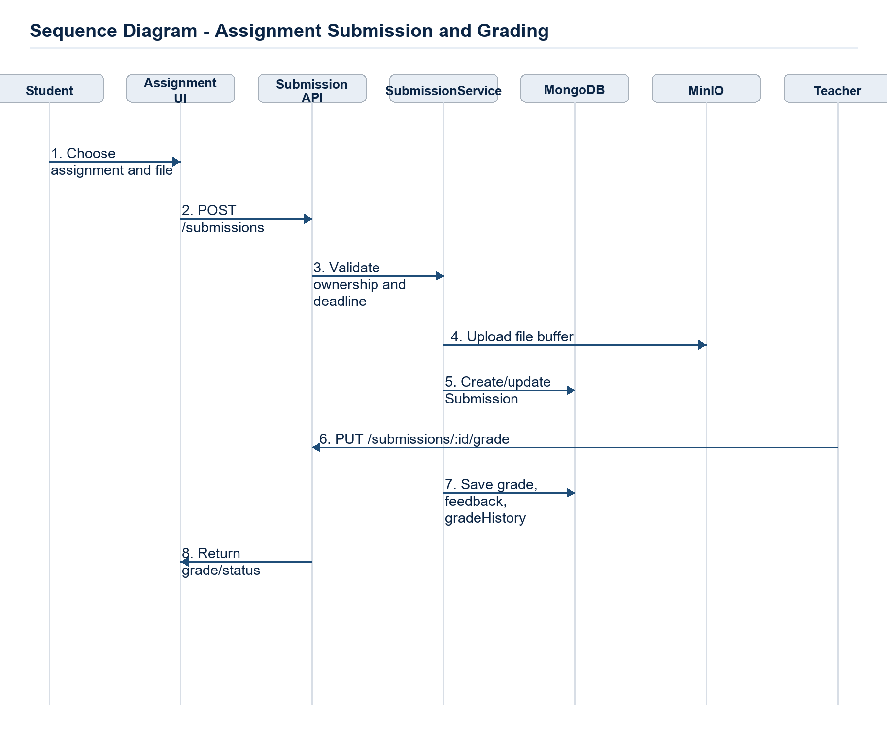
Sequence Diagram - Assignments, Submissions & Grading.

3.6 Schedule & Attendance
Quản lý lịch học, ca học, ngoại lệ lịch và điểm danh; tự động cảnh báo vắng khi vượt ngưỡng.
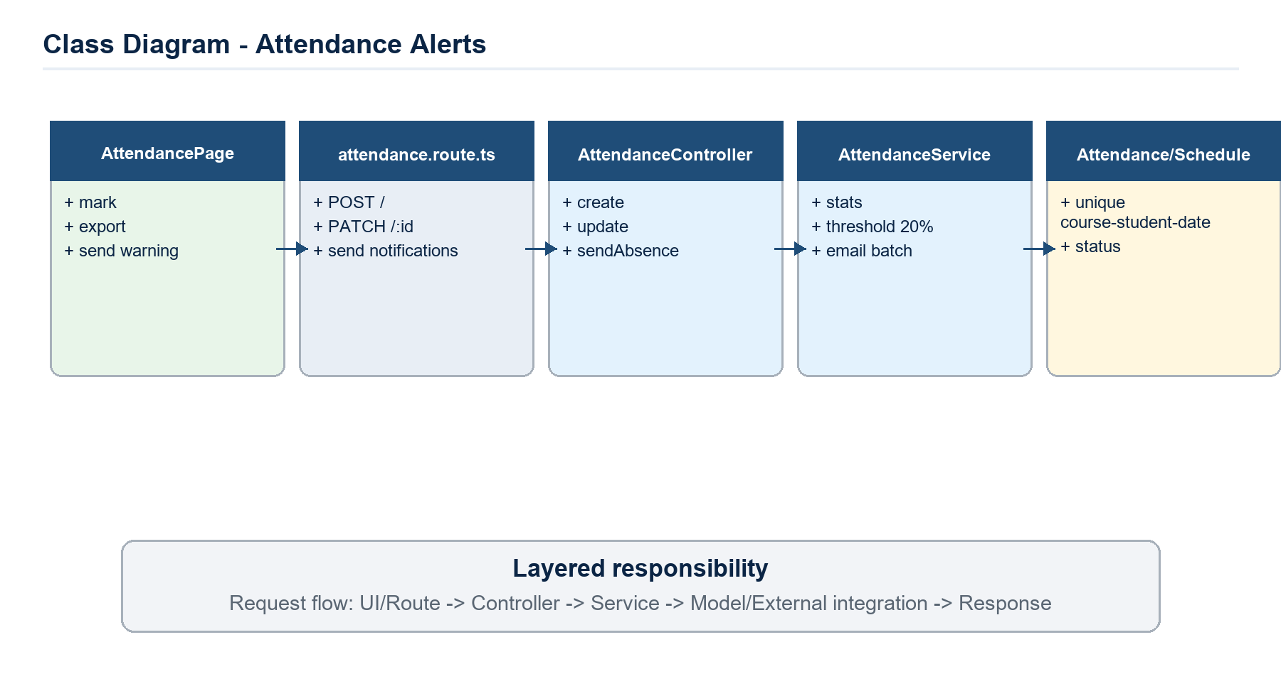
Class Diagram - Schedule & Attendance.
Class / Module | Specification
ScheduleService | time slots, teacher availability, pending approve, exceptions.
AttendanceService | create/update/delete/export, course/student stats, absence warning.
TimeSlotModel | slotNumber, start/end, applicableDays.
ClassScheduleModel | courseId, teacherId, dayOfWeek, timeSlotId, status.
AttendanceModel | courseId, studentId, date, status, markedBy.

Main sequence and business flow:
- Teacher/Admin tạo schedule request; service kiểm tra availability và unique active teacher-day-slot.
- Admin approve schedule hoặc schedule exception để chuyển trạng thái hợp lệ.
- Teacher mark attendance theo course/date; service lưu unique courseId+studentId+date.
- Khi gửi cảnh báo, service tính số buổi absent; threshold mặc định 20% và gửi email qua Resend cho học viên liên quan.
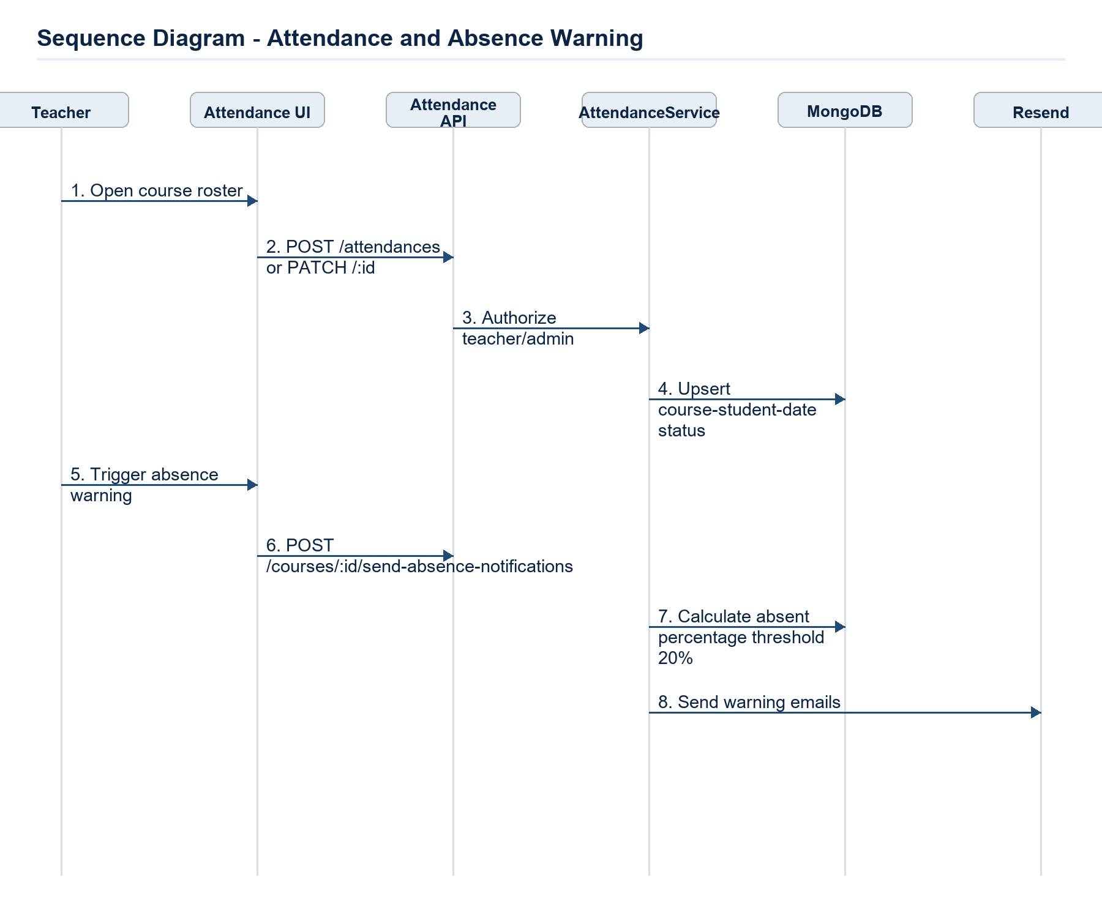
Sequence Diagram - Schedule & Attendance.

3.7 Forums, Chat Rooms & WebRTC Video Calls
Thiết kế tương tác realtime: forum theo course, chat room, tin nhắn file, typing/unread và WebRTC signaling.
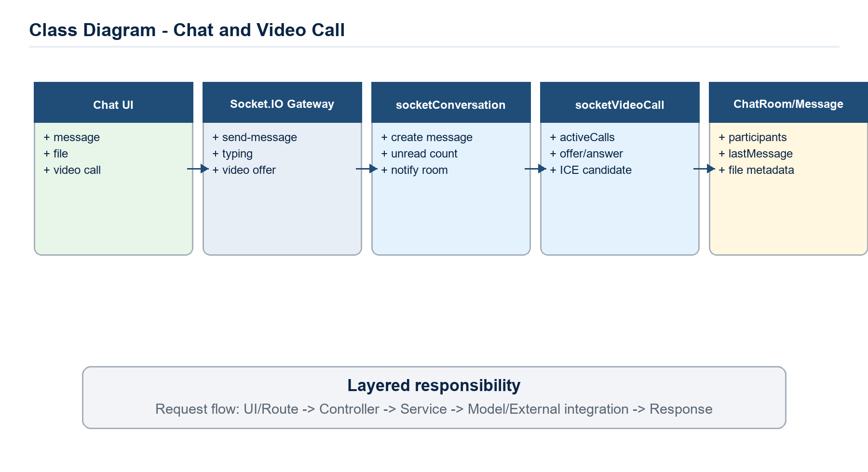
Class Diagram - Forums, Chat Rooms & WebRTC Video Calls.
Class / Module | Specification
ForumController/Service | forum, post, reply CRUD with course context.
SocketAuthMiddleware | Đọc accessToken từ cookie, verify JWT, attach socket.user.
socketConversation | send message/file, mark as read, invite/leave/join room.
socketVideoCall | activeCalls map, start/join/leave/offer/answer/ICE/end.
ChatRoom/Message | participants, unreadCounts, lastMessage, file metadata.

Main sequence and business flow:
- Socket connection được xác thực bằng accessToken cookie; user join room riêng của mình và các chatRoom đang tham gia.
- Gửi message: socketConversation tạo Message, cập nhật ChatRoom.lastMessage/unreadCounts và emit chatroom:new-message.
- Gửi file chat: file buffer được upload lên MinIO, Message lưu file metadata rồi broadcast về room.
- Video call: socketVideoCall tạo callId, quản lý activeCalls/userCalls và relay offer/answer/ICE để client thiết lập WebRTC peer-to-peer.
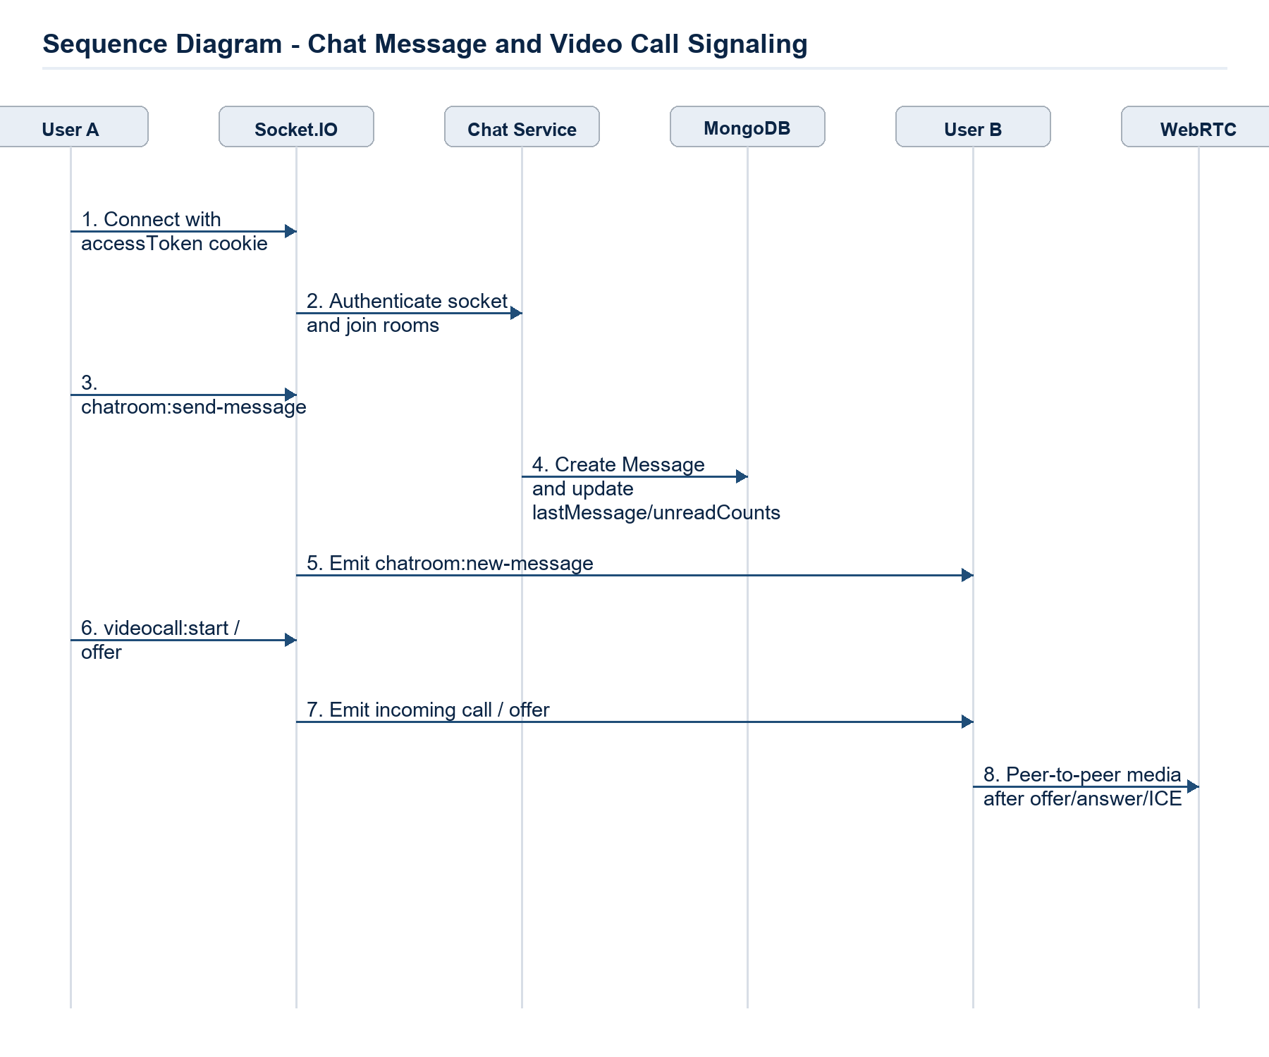
Sequence Diagram - Forums, Chat Rooms & WebRTC Video Calls.

3.8 Feedback, Announcements, Notifications & Blog
Bao phủ các luồng phản hồi, thông báo khóa học/hệ thống, notification đọc/chưa đọc và bài viết public.
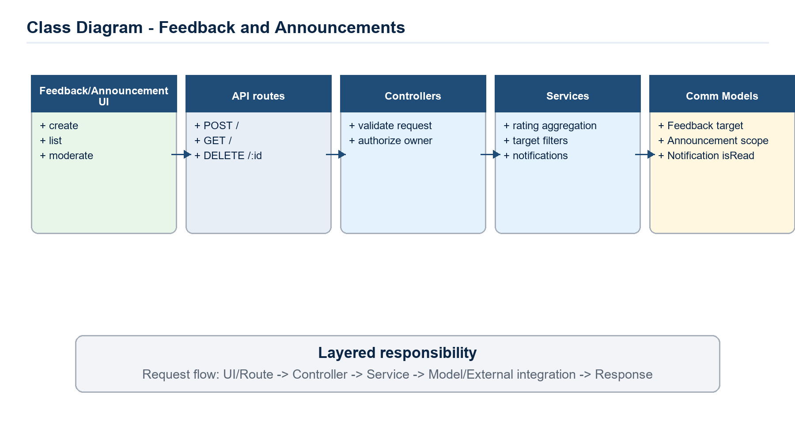
Class Diagram - Feedback, Announcements, Notifications & Blog.
Class / Module | Specification
FeedbackController/Service | create, list by target, my-feedbacks, delete moderation.
AnnouncementController/Service | course/system announcement CRUD.
NotificationService | create notification, read/read-all, soft/hard delete.
BlogController/Service | public CRUD by slug.
Feedback/Announcement/Notification/Blog | supporting communication models.

Main sequence and business flow:
- Student gửi feedback có title, description, rating và optional attachment; service lưu targetId/type và file metadata nếu có.
- Teacher/Admin tạo announcement; route yêu cầu authenticate và service lưu course/system scope.
- Notification được tạo bởi các service khác khi enrollment/course/chat thay đổi; user đọc qua /notifications và mark read/delete.
- Blog public có slug unique và text index để hiển thị nội dung landing/knowledge sharing.
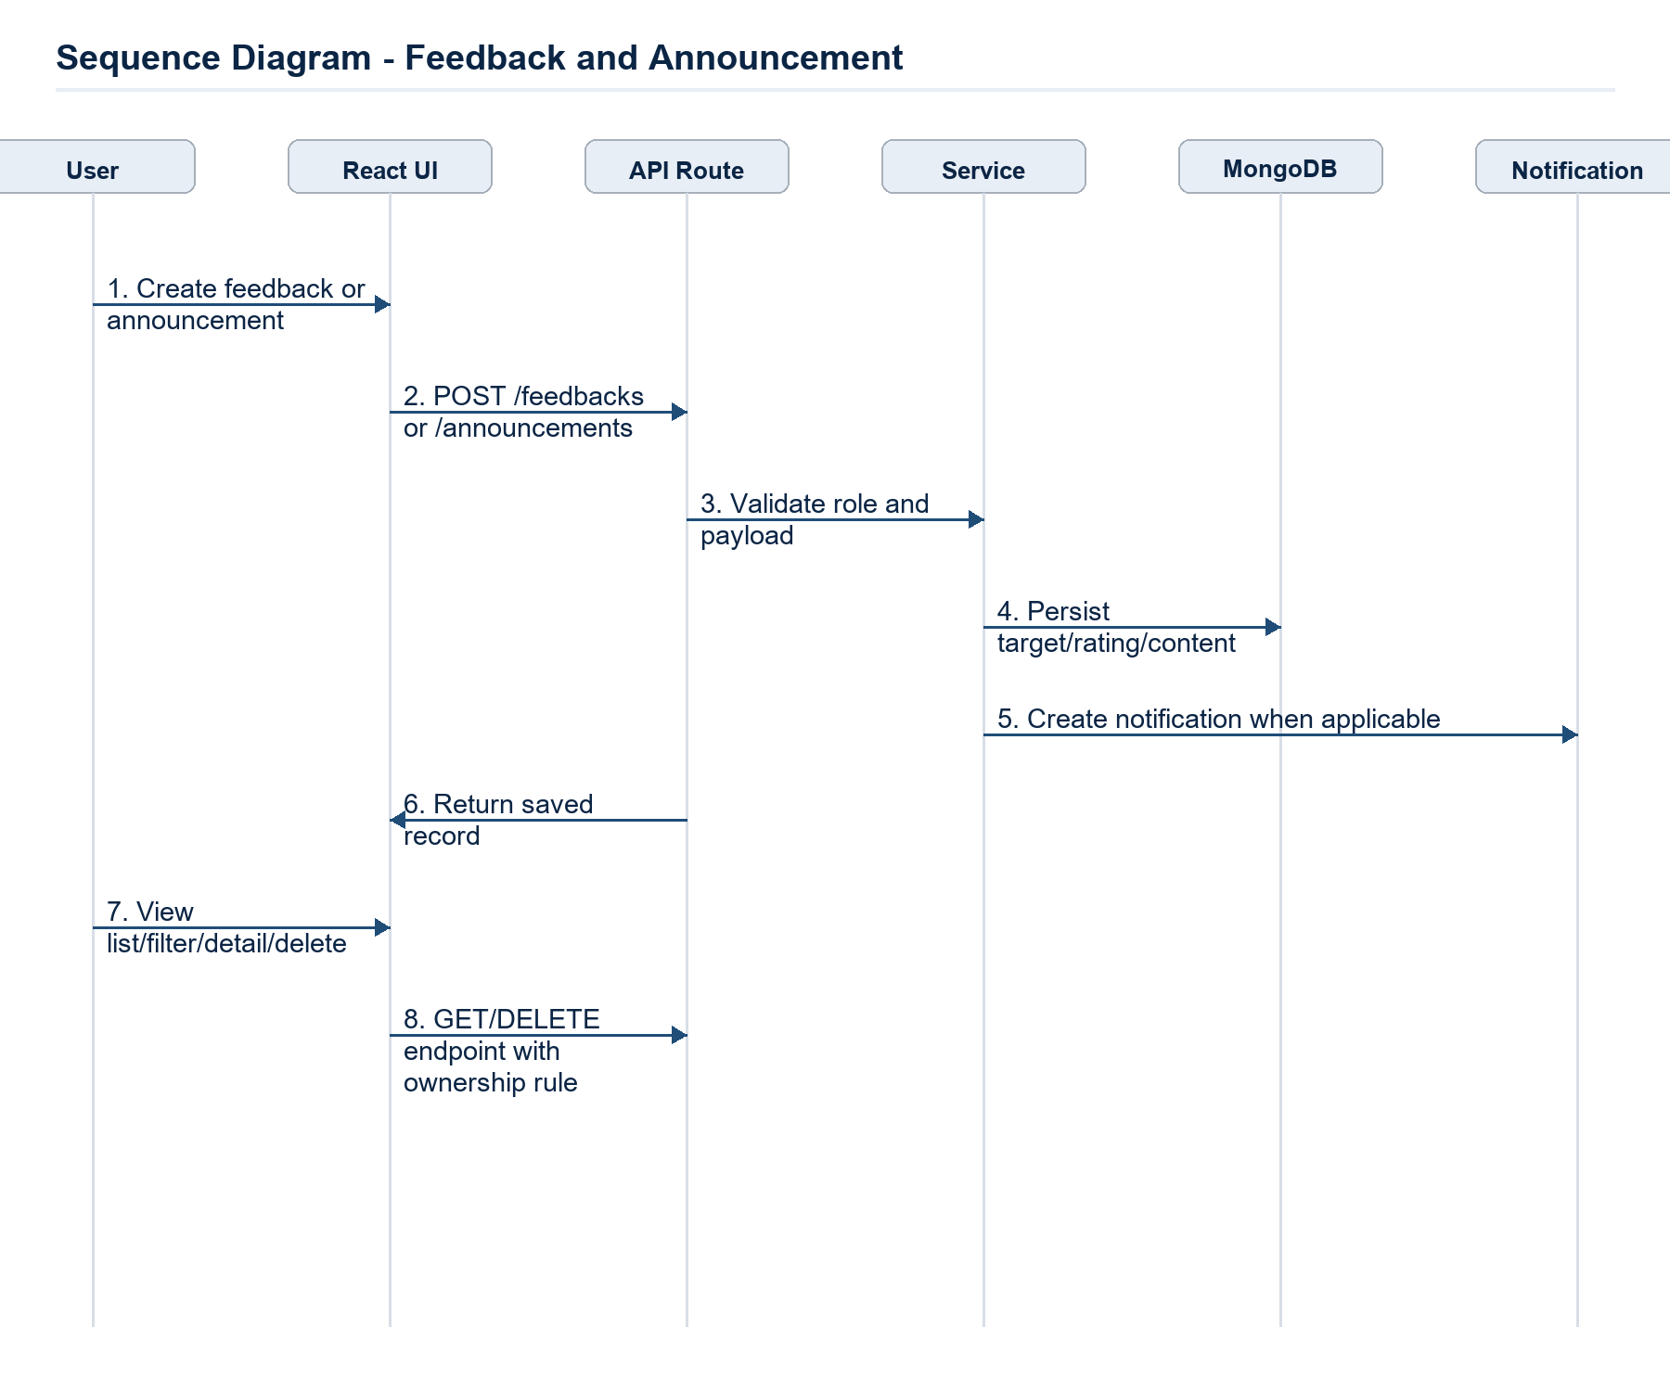
Sequence Diagram - Feedback, Announcements, Notifications & Blog.

3.9 Cross-Cutting Design Decisions
Concern | Design Decision
Authentication | JWT accessToken and refreshToken are stored as HTTP-only cookies. refreshToken maps to SessionModel, not localStorage.
Authorization | Protected routes use authenticate and authorize(Role...). Socket.IO uses socketAuthMiddleware to verify the same access token from cookies.
Validation | Validators parse request DTOs before service logic; services still enforce domain rules and ownership checks.
Error handling | Services use appAssert/AppError with HTTP constants; errorHandler centralizes failure responses.
File upload | Multer memoryStorage enforces MIME allow-list and 20MB limit, then uploadFile streams buffer into MinIO/S3.
Soft delete | Course and notification-like flows preserve history using isDeleted/deletedAt/deletedBy where applicable.
Realtime | Socket events update MongoDB first, then emit to chat room/user rooms to keep UI state consistent.
Observability | Service-level indexes and filtered queries support pagination, stats, text search and role-scoped access.

3.10 Traceability Summary
Business Area | Code Evidence | Covered Flows
Authentication & Users | auth.route.ts, auth.controller.ts, auth.service.ts, user/session/verificationCode models | Register, verify email, login, Google login, refresh, logout, reset password, profile/user management.
Course & Enrollment | course/enrollment/subject/courseInvite services and models | Course creation, publish, soft delete, self-enroll, invite join, prerequisite, capacity and cooldown.
Learning Content | lesson, lessonMaterial, lessonProgress modules | Lesson CRUD, material upload/download, presigned URL, time-on-task and completion.
Assessment | quiz, quizQuestion, quizAttempt, assignment, submission modules | Question import/export, quiz attempt auto-save/submit/regrade/ban, assignment submission/grading/report.
Schedule & Attendance | schedule, timeSlot, scheduleException, attendance modules | Weekly schedule, exception approval, attendance marking, exports and absence email warning.
Communication | forum, chatRoom, message, notification, announcement, feedback, blog, socket modules | Forum threads/replies, realtime chat, WebRTC signaling, notifications, announcements, ratings and public posts.

